**NAME :** PRIYADHARSHINI.V

**DEPARTMENT :** BE.BIO MEDICAL ENGINERRING

**COLLEGE :[8151]**DHANALAKSMI SRINIVASAN INSTITUTE OF TECHNOLOGY ,SAMAYAPURAM,TRICHY.

**NAAN MUDHALVAN COURSE:** DIGITAL MARKETING

**NAAN MUDHALVAN ID :** 2A65B41F868B2CD825644D0048066E28

**ASSIGNMENT QUESTIONS ON DIGITAL MARKETING**

1. Create a blog or website using Blogspot and Wordpress.Customize the theme design and post new article with 500 words

Blogspot URL:

<https://dazzling> cosmetics.blogspot.com

Wordpress URL:

<https://dazzlingdudezz.wordpress.com/2023/10/17/21/>

1. Create a New Facebook Business Page and post one social media poster for your brand.

<https://www.facebook.com/Dazzling>dudezz

3.Create and design a social media advertisement poster using canva.

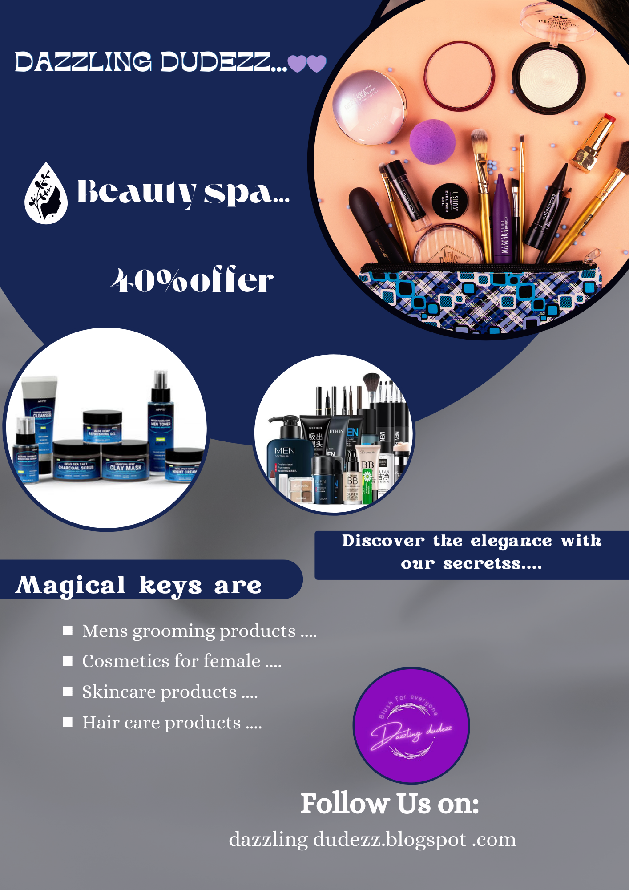

1. Create email newsletter design using MailChimp or Canva tool.

